**3.1 Problem Definition**

Traditional digital platforms handle either **media streaming** or **file sharing**, but not both together in a single integrated system. This separation causes several challenges:

* **Limited Functionality**  
  • OTT platforms only focus on streaming content; they lack offline local file-sharing options.
* **Connectivity Issues**  
  • OTT services require a stable internet connection, while file sharing often needs external apps.
* **Time Consuming**  
  • Switching between multiple apps (OTT for streaming and another for sharing files) wastes time.
* **Privacy Concerns**  
  • Using third-party apps for file sharing can risk personal data exposure.
* **Lack of Integration**  
  • No single solution currently combines OTT streaming and local peer-to-peer file sharing.

The proposed **“Local Send” project** integrates **OTT media services** and **Local File Sharing** into a **single software platform**. It enables users to **stream and access digital media** while also **sharing files securely over local Wi-Fi or hotspot**, ensuring both entertainment and productivity in one application.

**3.2 Requirement Specification**

The requirements for the system are divided into **Functional** and **Non-Functional**.

**Functional Requirements**

* **User Management**: Register, login, profile update, subscription management.
* **OTT Module**: Browse, stream, and download content (movies, shows, media).
* **File Sharing Module**: Peer-to-peer file transfer across local devices.
* **Device Discovery**: Automatic detection of nearby devices for file transfer.
* **Transfer Management**: Pause, resume, or cancel ongoing file transfers.
* **Notifications**: Alerts for new OTT content, incoming files, or completed transfers.
* **Reports & Logs**: Track user activities, subscriptions, and file transfers.

**Non-Functional Requirements**

* **Performance**: Smooth video playback (OTT) and high-speed Wi-Fi file transfer.
* **Security**: Encrypted streaming and end-to-end secure file transfers.
* **Usability**: Unified interface for OTT streaming and file sharing.
* **Scalability**: Support for multiple users and devices.
* **Reliability**: Works offline for local file sharing and online for OTT streaming.
* **Maintainability**: Modular design for easy upgrades and bug fixes.

**3.3 Planning and Scheduling**

**3.3.1 Gantt Chart**  
Project phases include:  
Requirement Gathering → Design → OTT Module Development → Local Send Module Development → Integration → Testing → Deployment → Maintenance

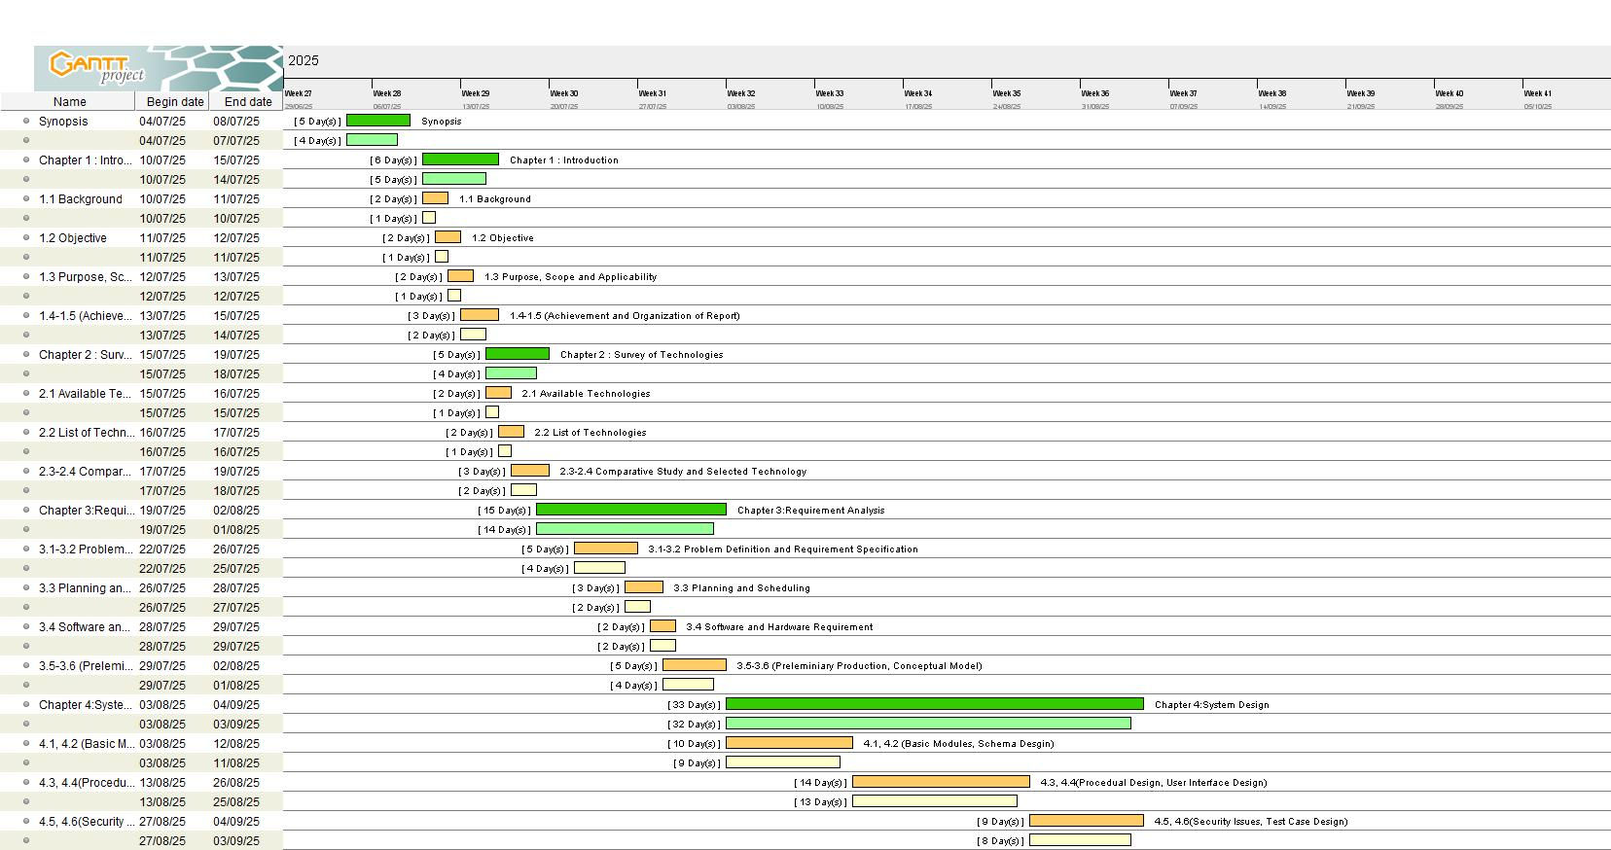

**3.3.2 PERT Chart**  
The PERT chart will show dependencies such as:

* UI/UX design
* Backend setup
* OTT content integration
* File transfer protocol setup
* Testing and deployment

**3.4 Software and Hardware Requirements**

**3.4.1 Developer Requirements**

**Hardware**

* Laptop/PC with Intel i3 or above (i5 recommended)
* 8 GB RAM or higher
* 2 GB free storage for project files and database

**Software**

* OS: Windows/Linux
* IDE: Visual Studio Code / Android Studio
* Frontend: React / Flutter (for cross-platform UI)
* Backend: Node.js / Python Flask
* Database: MySQL / MongoDB
* Version Control: GitHub

**3.4.2 User Requirements**

**Hardware**

* Smartphone or PC with internet and Wi-Fi capability

**Software**

* Any modern web browser or dedicated mobile app for OTT + Local Send

**3.5 Preliminary Product Description**

The **Local Send OTT + File Sharing Platform** is a **cross-platform application** that integrates both entertainment and utility features.

**Users can:**

* Register/Login and manage subscriptions
* Stream OTT content (movies, TV shows, music, etc.)
* Discover nearby devices
* Send and receive files locally without internet
* Monitor transfer and streaming status

**Admins can:**

* Manage content library (OTT)
* Monitor transfer history
* Handle subscription and access control
* Configure updates and bug fixes

This ensures an **all-in-one platform** that provides both **media streaming** and **local file transfer**.

**3.6 Conceptual Model**

**3.6.1 Use Case Diagram**  
The Use Case Diagram for **Local Send** includes interactions such as:

* User browsing and streaming OTT content
* User discovering nearby devices
* Sending and receiving files
* Admin managing content, subscriptions, and reports

**Actors With Respect to Project:**

1. User
2. Admin
3. Server

**Use Cases for User:**

1. Registration / Login
2. Browse Files
3. Send File
4. Receive File
5. Stream Content
6. Pause/Play Media
7. View Media Recommendations

**Use Cases for Admin:**

1. Login
2. Manage Users
3. Upload Content
4. Manage Content
5. Generate Reports
6. Monitor Server

**Use Cases for Server:**

1. Authenticate Users
2. Route Files
3. Stream Media
4. Transcode Media (if applicable)
5. Monitor Activity

**3.6.2 Data Flow Diagram**

**Definition:**

A Data Flow Diagram (DFD) is a visual representation of the flow of data through a system, highlighting the inputs, processing, and outputs. A neat and clear DFD can depict a good amount of the system requirements graphically, it makes easy for the business requirements of applications by representing the sequence of process steps by step. It shows how data enters and leaves the system, what changes theinformation, and where data is stored. The DFD is also called as a data flow graph or bubble chart.

**Components**

|  |  |  |
| --- | --- | --- |
| **Component**  **Names** | **Symbol** | **Description** |
| **Process** |  | **Processes represent activities or functions that transform input data into output data. They are the actions performed on data within the system.** |
| **Data Source** |  | **Data Stores represent repositories where data is stored. They can be databases, files, or any other storage location. Data flows in and out of these stores through processes.** |
| **External Entity** |  | **External Entities are sources or destinations of data that interact with the system but are outside of it. They represent users, other systems, or external data sources.** |
| **Data Flow** |  | **Data Flows depict the movement of data between processes, data stores, and external entities. They indicate how data is transferred, processed, or stored within the system.** |

**Table 3.3 Data Flow Diagram.**

**Entities Used:**

1. User
2. Admin
3. External Media Sources

**Processes:**

1. Authentication Process (handles login).
2. File Sharing Process* (handles LAN file transfers).
3. Media Streaming Process(handles OTT streaming).
4. Content Management Process (administers media content).
5. Report Generation Process (generates reports for admin).

**Data Stores:**

1. User Database: Stores user data and preferences.
2. File Database: Stores file transfer information.
3. Media Database: Stores media content for streaming.
4. Report Database: Stores activity reports (optional).